As of November 19, 2025

Telecommunications
- State monitoring (“health monitoring”)
  - Battery health and power management/usage
  - (G-force indicator sensor)
  - (Geigar sensor)
  - Safety report
- GUI
- Video streaming
- Two channels:
  - LoRa RF (Teensy through Wio Tracker L1)
  - WiFi (Jetson)
- Coordination with electrical team for reliable communications
  - Latency
  - Protocols
- ROS 2

Control
- Autonomous
  - Aruco scanning and detection software
- Semi-autonomous
- Manual
- Types of perception:
  - Proprioception
  - Exteroception
  - Exproprioception
- Robotic arm control
  - (Be able to open and close a door)
- Homeostatic regulation
- Fail safe behavior

Reactive Functionality
Example:
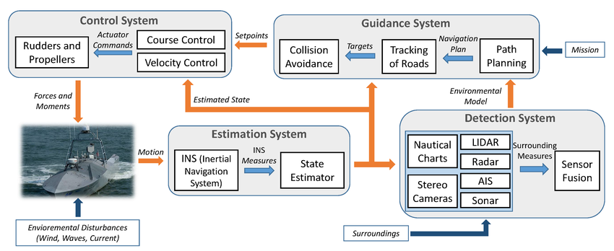

GPS
- Record coordinates
- Record route taken to a site
- Path creation
- Does not work indoors and signal can be interfered with by external objects outside

Movement
- Sensors:
  - IR
  - Sonar
  - Gyroscopic
  - Shaft encoders
  - INS
  - IMU
- Generating reference trajectory
- Determining velocity

